+

July 17-21, 2024 found many Catholics – nearly 60,000 according to some estimates, meeting together in Indianapolis, Indiana for the 10th National Eucharistic Congress. It was a truly blessed time to worship our God with so many fervent faith-filled Catholics, young and old, from around the country. Jesus is fully present in all the tabernacles throughout the world… and oh… it was a mountain-top experience to gather during those five days! Words cannot begin to capture all of the graces of those days, but a few of those that most come to mind and heart are described below.

The opening night’s events were absolutely awe-some. First, the perpetual pilgrims from the four pilgrimage routes entered the packed Lucas Oil Stadium. Then, the stadium was brought into darkness… a voice recounted that the Creator of all things seen and unseen must be obeyed by matter – so when He said, “Let there be light” there *was* light. Images of light flooded the screens. When Jesus spoke to the bread and said, “This is my body” the matter (bread) *had* to obey the word of the Word… and become the Body of Jesus. After the words, “HE IS HERE!” we were invited to “kneel if you are able.” The faithful fell silent and to their knees as Jesus entered in a large and beautiful monstrance carried by Bishop Cozzens. How very fitting to begin the National Eucharistic Congress with adoration! I encourage you to watch the opening night’s video – <https://www.youtube.com/watch?v=0H1u_1rW0yQ> (the part just described begins about 1:10 into it).

The next days were filled with amazing Masses, powerful talks, breakout sessions, and evening revival sessions that included time of adoration. Friday night’s *Litany of Healing and Repentance* led by Father Boniface Hicks, OSB was a notable time of healing: printed version of the Litany at <https://imf.saintvincentseminary.edu/litany/> and a video at <https://www.youtube.com/watch?v=L1PQGpdP64c>).

On Saturday, there was a Eucharistic Procession on a mile-long route from the Convention Center to the War Memorial. It was such a humbling privilege to process in front of Jesus, passing through thousands of His friends who lined the streets to show their love and devotion to our Lord in the Blessed Sacrament.

This 40 second timelapse shows the Eucharistic Procession moving through the streets of downtown Indy. <https://x.com/EWTNews/status/1814781047424295226>

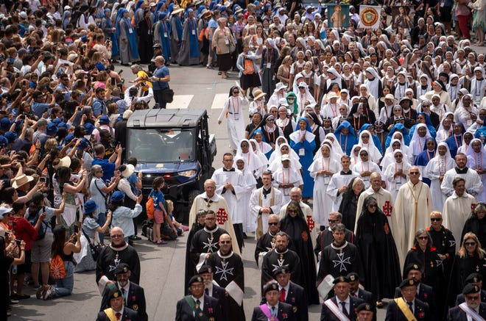It was not lost on me that the procession ended with Adoration and Benediction at the Indiana ***War******Memorial***. If you think about it, the Eucharist really is a *memorial* of the greatest spiritual war ever fought! Pope John Paul II issued an encyclical on the Eucharist, and spoke of the “memorial” aspect of the Eucharist.

*“When the Church celebrates the Eucharist, the* ***memorial*** *of her Lord's death and resurrection, this central event of salvation becomes really present and “the work of our redemption is carried out”. This sacrifice is so decisive for the salvation of the human race that Jesus Christ offered it and returned to the Father only after he had left us a means of sharing in it as if we had been present there. Each member of the faithful can thus take part in it and inexhaustibly gain its fruits. This is the faith from which generations of Christians down the ages have lived. … What more could Jesus have done for us? Truly, in the Eucharist, he shows us a love which goes “to the end” (cf. Jn 13:1), a love which knows no measure.”* [*https://www.vatican.va/content/john-paul-ii/en/encyclicals/documents/hf_jp-ii_enc_20030417_eccl-de-euch.html*](https://www.vatican.va/content/john-paul-ii/en/encyclicals/documents/hf_jp-ii_enc_20030417_eccl-de-euch.html)

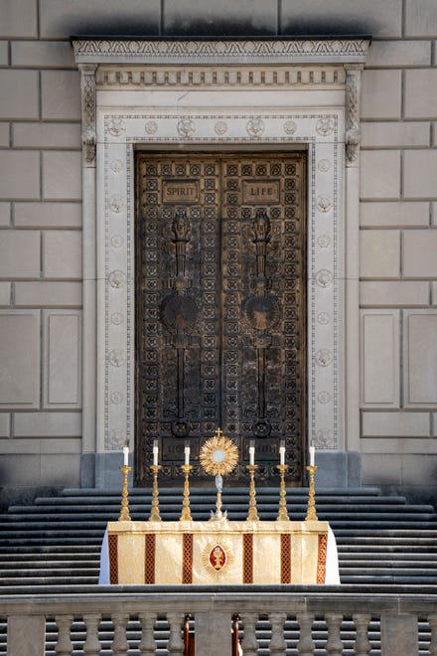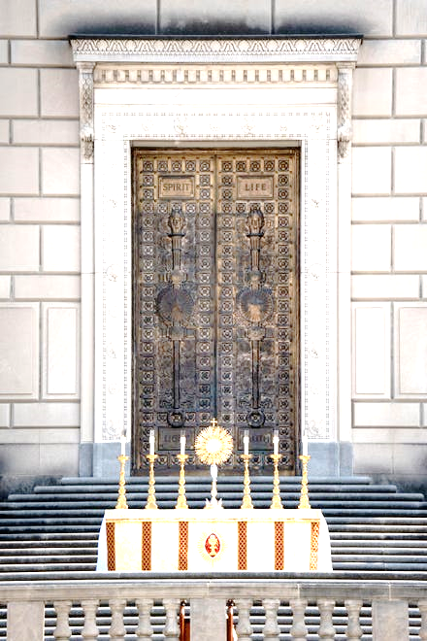

The bronze doors of the War Memorial behind our Eucharistic Lord say “**Spirit**” and “**Life**” which Jesus spoke of in John 6:63, the great *Bread of Life* discourse. “It is the spirit that gives life, while the flesh is of no avail. The words I have spoken to you are spirit and life.” He had just told the crowd that he was going to give his body and blood for food and drink, and some had difficulty accepting that and walked away. When Jesus challenged the Apostles, “Do you also want to leave?” Saint Peter made a beautiful act of faith, “Master, to whom shall we go? You have the words of eternal life. We have come to believe and are convinced that you are the Holy One of God.” Oh, it is *delightful* to remember that the War Memorial was constructed beginning in 1926, so nearly 100 years ago, God was preparing the site for **this** Eucharistic Procession!

Some of the 150 of the Nashville Dominicans found Bishop Spalding after the Eucharistic Procession.

At the closing Mass, we were sent forth as missionaries and encouraged to ***Walk with One***, to walk with someone to the Eucharist and Sacraments on his or her journey home to the Church. <https://www.eucharisticrevival.org/walk-with-one>.

There are many inspiring articles and videos of talks available online, including many of the talks being available at EWTN’s <https://www.youtube.com/playlist?list=PL9CQlldupc5-TAMz3fOlJwyBO3zWLQFVv>

What a blessing to have been able to attend – thank you, Jesus! May this National Eucharistic Congress bear much fruit in your Vineyard and in each of our hearts.

***Sister Mary Peter, O.P.***